QUALITY & FOOD SAFETY POLICY

‘World of Spice’ specialises in the development, production, packing and sale of dehydrated herbs and spices, and products manufactured from dehydrates and other food ingredients from all parts of the world. It is a supplier to the wholesale catering trade.

Believing that our competitive strategy should emphasise the production of safe, legal, authentic products to the specified quality, we achieve this by a process of teamwork and continuous improvement of a food safety and quality culture, which is reflected in the commitment to quality of performance by each and every employee towards our customers.

The company’s Director/General Manager provides the human and financial resources required to produce food safely and in compliance with the requirements of this Standard.

The quality system and supporting procedures have been prepared to satisfy national and international Quality System requirements as required by the BRCGS for Food Safety, issue 9, Conformance to these systems is mandatory for all personnel within the organisation.

The company is totally committed to these objectives and to a policy of review and continuous improvement.

Signed ………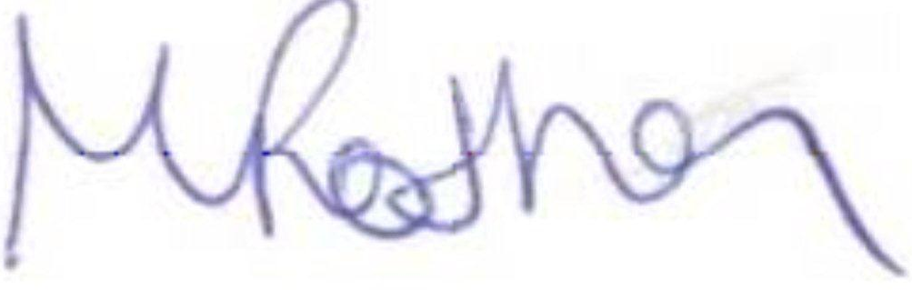………………………………………….

M Rothon
Director/General Manager

